***Journal for tutorial***

29/10/2024

Reflection on Movement Tutorial:

Today, I decided against adding a Rigidbody component to the cube for the movement mechanic. My reasoning was that it would introduce unnecessary complexity for this beginner-level tutorial. While using a Rigidbody could provide more realistic physics-based movement, I opted for simplicity to ensure that the tutorial remained accessible to beginners. I also considered how this decision would affect the tutorial's clarity and usability for others who might follow it.

What I Learned:

Keeping tutorials focused on the basics is key for beginner-friendly materials.

Sometimes, simplicity is more effective than adding extra features.

03/12/2024

Reflection on version control with GitHub:

I faced a challenge while pushing my Unity project files to GitHub. Initially, I thought the process was straightforward, but I learned the importance of double-checking the repository structure after each push. When I created a new extension for pushing the files, it generated a secondary folder with dashes in the name, which caused the files to be misplaced. This error meant that my GitHub repository on another computer did not contain all the necessary files. I had to return to the original computer to resolve the issue.

What I Learned:

Always verify that the files are correctly pushed to GitHub by reviewing the repository structure.

Avoid unnecessary renaming or restructuring of folders during the push process.

Double-check the GitHub repository from a different computer to ensure everything is accessible.

What I Plan to Do Moving Forward:

Use GitHub Desktop or a command-line interface to manage file pushes more effectively.

Create a checklist for pushing projects to GitHub to ensure every step is completed.

Test the repository on another device immediately after pushing files.

10/12/2025

Project name: (Changing an object’s color)

When attempting to create a new repository in GitHub Desktop, I encountered the following error message:

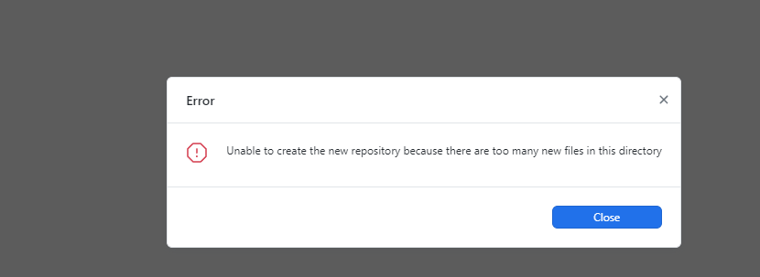

This disallowed me to submit my work on time because of these technical difficulties.

12/01/2025

Following this, I encountered another issue while trying to push the game to GitHub. After considering the challenges, I decided to zip the project folder and submit the zipped file through the VLE, following Paul’s suggestion. However, I came across another problem. The file size was too large for submission, preventing me from uploading it successfully.

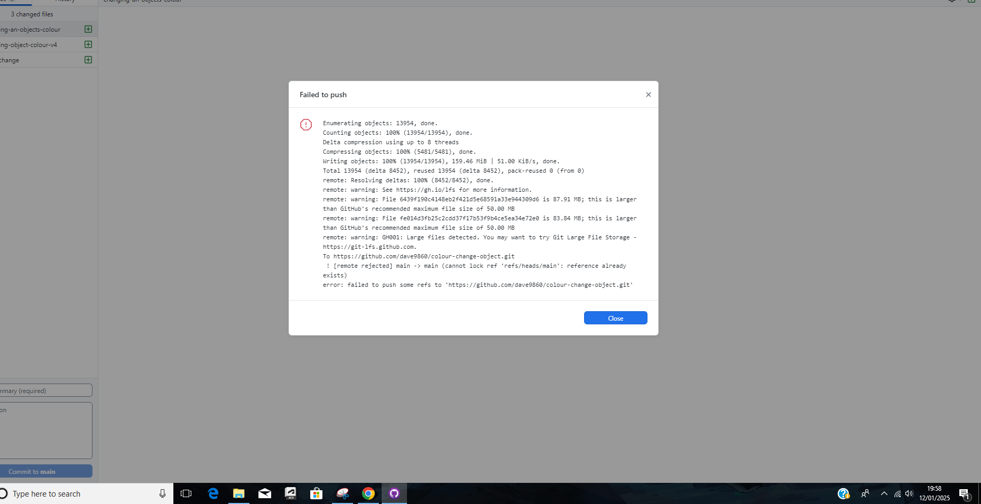

12/01/2025

Eventually I kept on trying and I believe I was able to push it through GitHub with pure luck.